Pterial Airport Logistic Suite (PALS)
SAC Application
Installation Guide

Document No.: PALS-SAC-IG
Project No.: PSHIA
Author: HS Chia
Release Date: 02-Nov-2009
Revision: 1.00
Pages: 39

Copyright © Pteris Global Limited 2009. All Rights Reserved.

Transmittal, reproduction, dissemination and/or editing of this document as well as utilization of its contents and communication thereof to others without express authorization are prohibited. Offenders will be held liable for payment of damages. All rights created by patent grant or registration of a utility model or design patent are reserved. In case the contractual agreement allows the customer to change the document such changes shall be clearly highlighted and shall name the person changing the document. In any case Pteris Global Limited is not liable for any amendments or changes in the document and any possible consequences there from.
All trademarks and registered trademarks are the property of the respective owners. The use of registered names, trade names, description of goods etc. in this document, even if not specially identified as such, does not imply that such names may be regarded as free in the sense of legislation pertaining to registered trademarks and the protection of trademarks and may therefore be used by anyone..

Responsible for the contents
Pteris Global Limited
Singapore

Revision
Version | Release | Date | Init. | Description
1 | 00 | 02-Nov-2009 | HSC | Initial version.

Contents
Contents 4
1. Overview 5
1.1 PALS Application Folder Hierarchy 5
1.2 PALS Application Files 5
2. Release 1.0.0 (14 oct 2009) 7
3.1 Pre-requirement of Installation 7
3.1.1 Server Hard Disk Partition Requirement 7
3.1.2 Microsoft .NET Framework (V3.5) Requirement 7
3.1.3 Windows EventLog Configuration Requirement 8
3.2 Installation Instruction 11
3.2.1 SAC Application Installation 11
3.3 Post Installation Instruction 14
3.3.1 SAC Service XML Configuration File 14
3.3.2 PALS.MessageRouter Service XML Configuration File 35
3.4 Reboot SAC Server to Complete the Installation 37

Overview

PALS Application Folder Hierarchy
No. | Folder Name | Description
1 | C:\PterisGlobal\PALS\ | PALS application base path
2 | C:\PterisGlobal\PALS\SAC\ | PALS SAC application path
3 | C:\PterisGlobal\PALS\ReportViewer\ | PALS Report Viewer application path
4 | C:\PterisGlobal\PALS\MessageRouter\ | PALS Message Router application path
6 | C:\PterisGlobal\PALS\Scripts\ | PALS application script file path

PALS Application Files
This document is the installation instruction of MDS-CCTV interface application:
- PALS.SAC2PLC1GW – SAC to PLC1 communication gateway service
- PALS.SAC2PLC2GW – SAC to PLC1 communication gateway service
- PALS.SAC2PLC3GW – SAC to PLC1 communication gateway service
- PALS.SAC2PLC4GW – SAC to PLC1 communication gateway service
- PALS.SAC2PLC5GW – SAC to PLC1 communication gateway service
- PALS.SAC2PLC6GW – SAC to PLC1 communication gateway service
- PALS.SortEngine – GW to Sort engine service

All above services need to be installed on redundant SAC-COM servers in the BHS Control. The computer name of servers is “SAC-COM1”

Application File Folder Hierarchy
No | Folder | Files | Remark
1 | C:\PterisGlobal\PALS\SAC\ | 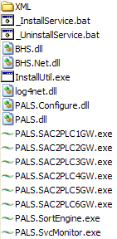 | - Application folders and files need to be copied in the C: drive;  - Directory of all application files (.EXE), function libraries files (.DLL), application XML configuration files (.XML), the service install/uninstall batch files (.BAT),
2 | C:\PterisGlobal\PALS\Scripts\ | 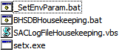 | Folder to backup previous version of application and configuration files before the new release files are installed.
3 | D:\ PterisGlobal\PALS\SAC\Log | *.log | - System log files need to be installed in the D: drive;  - Directory of SAC application log files (.LOG).

Release 1.0.0 (29 oct 2009)

Pre-requirement of Installation

Server Hard Disk Partition Requirement
SAC-COM1 servers shall have C: and D: two partitions. SAC application files will be installed in the C: drive. All logs that are created by SAC applications during the running time will be stored in the D: drive.

Microsoft .NET Framework (V3.5) Requirement
Microsoft .NET Framework version 3.5 is required by SAC2PLCGW Interface service applications.

If SAC-COM1 server do not have .NET framework or it is not version 3.5, you can download it from Microsoft web site and install it before proceed the SAC installations below.

Below picture shows how to check whether you have installed the v3.5 .NET Framework.
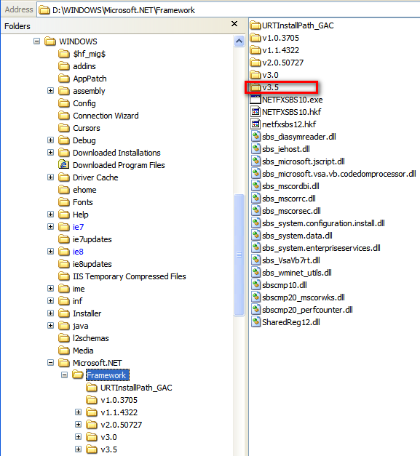

Windows EventLog Configuration Requirement
Follow Windows system event viewer configuration needs to be done on both SAC-COM1 server before other SAC installations.

Start the Event Viewer application:
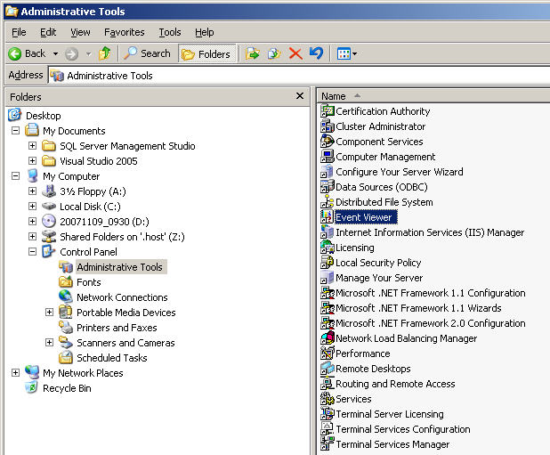

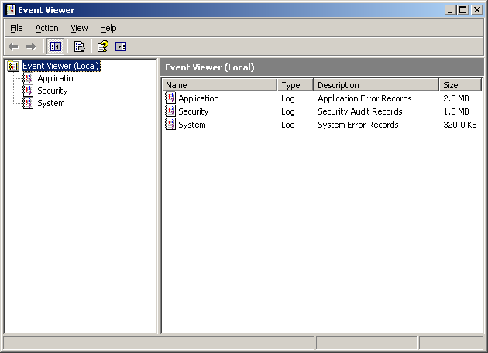

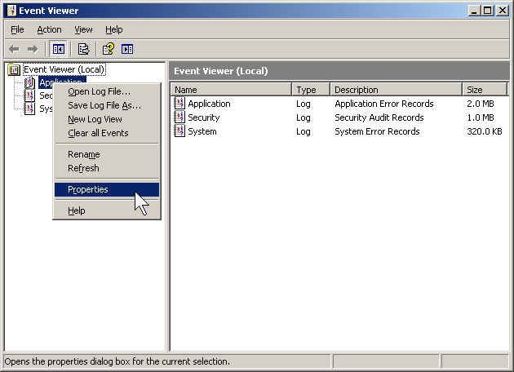
Right click on the “Application” and select “Properties”.

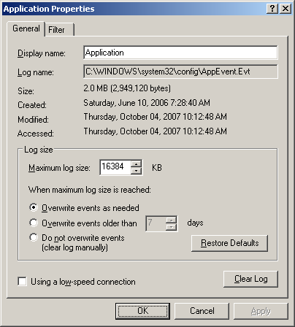
Make sure the “Overwrite events as needed” to be selected under the “Log size”. And then click “OK”.

Configure the same for “Security” and “System” in the Event Viewer.

Installation Instruction

SAC Application Installation
Step 1: Create folder “C:\PterisGlobal\PALS\SAC” and “C:\PterisGlobal\PALS\Scripts” on SAC-COM1 server;

Step 2: Copy following files from installation media into server folder “C:\PterisGlobal\PALS\SAC”:

Step 3: Copy following files from installation media into server folder “C:\PterisGlobal\PALS\Scripts”:
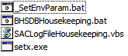

Step 3: From SAC-COM1 server, copy following files from folder “\PterisGlobal\PALS\SAC\XML\SAC1” on the installation media into SAC1 server folder “C:\PterisGlobal\PALS\SAC”:
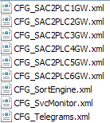

Step 4: From Windows Explorer on both SAC-COM servers, use mouse double click file “C:\ PterisGlobal\PALS\Scripts\_SetEnvParam.bat”. This batch file will create following two (2) Windows system environment parameters, which will be required by all SAC services, automatically:
- PALS_BASE = C:\ PterisGlobal\PALS
- PALS_LOG = D:\ PterisGlobal\PALS\Log

Step 6: From Windows Explorer on both SAC-COM servers, use mouse double click file “C:\ PterisGlobal\PALS\SAC\_InstallService.bat”. SAC services will be registered on both SAC-COM servers automatically by this batch file.
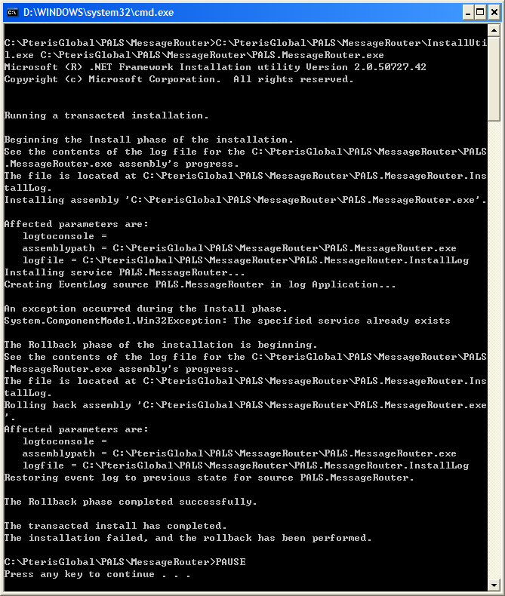

After service registration is completed, press any key to close the command window.

Open Service Manager to verify whether the services were registered successfully:
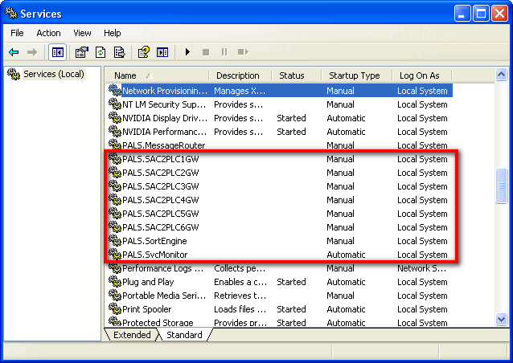

Note:
SAC services need to be registered once only at the first time of fresh installation. The new release files can be installed by just copy and overwrite the previous released files without re-register the service.

PLEASE DO NOT CONTINUOUSLY EXECUTE THE _INSTALLSERVICE.BAT
BATCH FILE MORE THAN ONE TIMES!

If you really need re-execute _InstallService.bat batch file, please unregister the services by execute the _UninstallService.bat batch file first.

Step 7: On SAC-COM servers, Modify XML configuration files according to the actual setting of individual BHS project. Please refer to section 2.3 (Post Installation Instruction) for the configuration file details.

Post Installation Instruction

SAC Service XML Configuration File
There are total eight SAC2PLCGW interface service applications are running on the SAC server. Each service has its own XML configuration file. They are:
No. | Service | Required Configuration File
1 | PALS.SAC2PLC1GW | CFG_SAC2PLC1GW.xml  CFG_Telegrams.XML
2 | PALS.SAC2PLC2GW | CFG_SAC2PLC2GW.xml  CFG_Telegrams.XML
3 | PALS.SAC2PLC3GW | CFG_SAC2PLC3GW.xml  CFG_Telegrams.XML
4 | PALS.SAC2PLC4GW | CFG_SAC2PLC4GW.xml  CFG_Telegrams.XML
5 | PALS.SAC2PLC5GW | CFG_SAC2PLC5GW.xml  CFG_Telegrams.XML
6 | PALS.SAC2PLC6GW | CFG_SAC2PLC6GW.xml  CFG_Telegrams.XML
7 | PALS.SortEngine | CFG_SortEngine.xml  CFG_Telegrams.xml
8 | PALS. SvcMonitor | CFG_SvcMonitor.xml  CFG_Telegrams.xml

In following XML configurations, only parameters highlighted in yellow color background need to be modified according to the actual configuration of SAC-COM1 servers. All other parameters should not be modified.

CFG_SAC2PLC1GW.xml to CFG_SAC2PLC6GW.xml configurations file settings:
The following apply to all SAC2PLCGW configuration files.
<?xml version="1.0" encoding="utf-8" ?>
<configuration>
<!-- This section contains the log4net configuration settings -->
<log4net>
<!-- Define some output appenders -->
<appender name="RollingLogFile" type="log4net.Appender.RollingFileAppender">
<param name="File" value="${PALS_LOG}\\SAC2PLC1.log" />
<param name="AppendToFile" value="True" />
<param name="DatePattern" value=".yyyyMMdd" />
<param name="RollingStyle" value="Date" />
<layout type="log4net.Layout.PatternLayout">
<param name="ConversionPattern" value="%d %-5p - %m%n" />
</layout>
</appender>
<!-- Setup the root category, add the appenders and set the default level -->
<root>
<!-- Level value can be ALL, DEBUG, INFO, WARN, ERROR, FATAL, OFF -->
<level value="ALL" />
<appender-ref ref="RollingLogFile" />
</root>
<!-- Print only messages of level INFO or above in the PALS framework package -->
<logger name="PALS.Net.Transports.TCP.TCPServer">
<level value="INFO" />
</logger>
<logger name="PALS.Net.Transports.TCP.TCPClient">
<level value="INFO" />
</logger>
<logger name="PALS.Net.Filters.Frame.Frame">
<level value="INFO" />
</logger>
<logger name="PALS.Net.Filters.Application.AppServer">
<level value="INFO" />
</logger>
<logger name="PALS.Net.Filters.Application.AppClient">
<level value="INFO" />
</logger>
<logger name="PALS.Net.Common.SocketChannel">
<level value="INFO" />
</logger>
</log4net>

<configSet name="GlobalContext">
<appName>SAC2PLC1GW</appName>
<company>PterisGlobal</company>
<department>CSI</department>
<author>HSChia</author>
</configSet>

<configSet name="[Channel:GW2Internal]PALS.Net.Transports.TCP.TCPClient">
<threadInterval>10</threadInterval>
<!-- valid values: True or False -->
<isAutoReconnect>True</isAutoReconnect>
<reconnectTimeout>10000</reconnectTimeout>
<!--Maximum length of name is 1~8 characters-->
<!--MDS2CCTVGW Svr IP: ?, CCTV Svr IP: ? -->
<localNode name="SAC2PLC1" ip="127.0.0.1" port="0"/>
<remoteNodes>
<!--SocketConnector object is able to connect to multiple remote TCP servers-->
<!--If there are more than one TCP server, just add following server element accordingly-->
<!--Maximum length of name is 8 characters-->
<server name="MSGROUTE" ip="127.0.0.1" port="26214"/>
</remoteNodes>
</configSet>

<configSet name="[Channel:GW2External]PALS.Net.Transports.TCP.TCPServerClient">
<!-- ChannelPath defines the direction of message transmission. -->
<!-- 0: via TCP Server channel, 1: via TCP Client channgel, 2: both Server & Client channels can have own in & out messages-->
<incomingChannelPath>2</incomingChannelPath>
<outgoingChannelPath>2</outgoingChannelPath>

<configSet name="TCPServer">
<threadInterval>10</threadInterval>
<!-- SAC Server 1 IP: 192.168.100.33, SAC Server 2 IP: 192.168.100.35, PLC01 IP: 192.168.100.91, PLC02 IP: 192.168.100.93,
PLC03 IP: 192.168.100.95, PLC04 IP: 192.168.100.97, PLC06 IP: 192.168.100.101 -->
<localNode name="SAC2PLC1" ip="127.0.0.1" port="44810"/>
<!--The minimum allowed client connections must be 1, only one remote TCP client is allowed to connect to current SAC2PLCGW service.-->
<maxConnections>1</maxConnections>
</configSet>
<configSet name="TCPClient">
<threadInterval>10</threadInterval>
<isAutoReconnect>True</isAutoReconnect>
<reconnectTimeout>20000</reconnectTimeout>
<!--Maximum length of name is 1~8 characters-->
<localNode name="SAC2PLC1" ip="127.0.0.1" port="0"/>
<remoteNodes>
<!--Maximum length of name is 8 characters-->
<server name="PLC01" ip="127.0.0.1" port="44818"/>
</remoteNodes>
</configSet>
</configSet>

<configSet name="PALS.Net.Filters.EIPCIP.EIP">
<!-- Socket connection will be closed if -
1) no RegisterSession Request received TCP connection has been opened for 5sec;
2) no RegisterSession Reply returned from remote after Request has been sent for 5sec.-->
<registerSessionTimeout>5000</registerSessionTimeout>
<!-- SenderContext = SAC2PLC1, Array of 8 USINT -->
<senderContext>83,65,67,50,80,76,67,49</senderContext>
<!-- Success status value = 0x0000, 4-byte integer -->
<successStatus>0,0,0,0</successStatus>
<!-- Unsupported EIP command status value = 0x0001 -->
<unsupportedCmdStatus>0,0,0,1</unsupportedCmdStatus>
<maximumDataFieldLength>1024</maximumDataFieldLength>
</configSet>

<configSet name="PALS.Net.Filters.EIPCIP.CIP">
<!-- outgoingQueueCapacity: the capacity of CIP class internal outgoing queue to buffer Table Write
Request messages. The next TWRQ message needs to be buffered in the queue to wait for TWRS (Response)
of last TWRQ message before it can be sent out. Default: 100 -->
<outgoingQueueCapacity>1500</outgoingQueueCapacity>
<!-- EIP and Socket connection will be closed if -
1) no Fwd_Open Request received after EIP connection has been opened for 5sec;
2) no Fwd_Open Response returned from remote after Request has been sent for 5sec.-->
<cipConnectionTimeout>5000</cipConnectionTimeout>
<!-- retriesForResponse: Resend times of CIP Connected message before close the CIP connection
because no response is returned from Target. Default: 1 -->
<retriesForResponse>3</retriesForResponse>
<!-- Success value of CIP General Status = 0x00, 1 byte integer -->
<successStatus>0</successStatus>
<!-- tableWriteSymbolPath: The default Tag name defined in the remote node to receive the
data table write messages from SAC2PLCGW Service. SAC-COM1: TAG_PLC1, SAC-COM2: TAG_PLC2 -->
<tableWriteSymbolPath>TAG_PLC1</tableWriteSymbolPath>
<!-- If SAC send message to PLC too fast, PLC could miss receiving some of them. Hence, the
message sending delay is implemented in SAC and it can be enabled by setting below. -->
<enableSendingDelay>True</enableSendingDelay>
<!-- the CIP Data Table Write Request sending delay time in milisecond. its value should be within 10~100ms. Default is 10ms. -->
<sendingDelayTime>10</sendingDelayTime>
<!-- the CIP Data Table Write Response sending delay time in milisecond. its value should be within 0~100ms. Default is 50ms. -->
<sendingCIPResponseDelayTime>50</sendingCIPResponseDelayTime>
</configSet>

<configSet name="PALS.Net.Filters.Frame.Frame">
<!--Only single character can be used as startMarker, endMarker, and specialMarker-->
<startMarker>02</startMarker>
<endMarker>03</endMarker>
<!--If the character of startMarker or endMarker is included in the outgoing-->
<!--data, the specialMarker is required to be prefixed in order to differentiate-->
<!--the start or end marker and the actual data character.-->
<specialMarker>27</specialMarker>
<!--If accumulated incoming telegram length has been more than maxTelegramSize-->
<!--(number of byte) but no EndMarker received, all accumulated data will be discarded.-->
<maxTelegramSize>10240</maxTelegramSize>
</configSet>

<configSet name="[Channel:GW2Internal]PALS.Net.Filters.Application.AppClient">
<threadInterval>100</threadInterval>
<!--Maximum length of clientAppCode is 8 characters-->
<clientAppCode>SAC2PLC1</clientAppCode>
<!--connectionConfirmTimeout value must bigger than the same parameter of bottom layer (RFC1006)-->
<connectionConfirmTimeout>3000</connectionConfirmTimeout>
<connectionRequestRetries>3</connectionRequestRetries>
<minSequenceNo>1</minSequenceNo>
<maxSequenceNo>9999</maxSequenceNo>
</configSet>

<configSet name="[Channel:GW2External]PALS.Net.Filters.Application.AppClient">
<threadInterval>100</threadInterval>
<!--Maximum length of clientAppCode is 8 characters-->
<clientAppCode>SAC2PLC1</clientAppCode>
<!--connectionConfirmTimeout value must bigger than the same parameter of bottom layer (RFC1006)-->
<connectionConfirmTimeout>3000</connectionConfirmTimeout>
<connectionRequestRetries>3</connectionRequestRetries>
<minSequenceNo>1</minSequenceNo>
<maxSequenceNo>9999</maxSequenceNo>
</configSet>

<configSet name="[Channel:GW2Internal]PALS.Net.Filters.SignOfLife.SOL">
<threadInterval>100</threadInterval>
<solSendTimeout>10000</solSendTimeout>
<solReceiveTimeout>25000</solReceiveTimeout>
</configSet>

<configSet name="[Channel:GW2External]PALS.Net.Filters.SignOfLife.SOL">
<threadInterval>100</threadInterval>
<solSendTimeout>10000</solSendTimeout>
<solReceiveTimeout>35000</solReceiveTimeout>
</configSet>

<configSet name="PALS.Net.Filters.TimeSynchronizing.TimeSync">
<!--threadInterval value must >=1000 (1 second) and <timeSyncInterval value -->
<threadInterval>1000</threadInterval>
<!--timeSyncInterval value must >=60000 (10 minutes) -->
<timeSyncInterval>3600000</timeSyncInterval>
<!-- (y)Year, (M)Month, (d)Day, (h)Hour, (m)Minute, (s)Second, (f)Millisecond-->
<dateTimeFormat>yyyyMMdd-HHmmssfff</dateTimeFormat>
</configSet>

<configSet name="PALS.Net.Filters.Acknowledge.ACK">
<threadInterval>100</threadInterval>
<retransmitBufferSize>1</retransmitBufferSize>
<retransmitTimeour>3000</retransmitTimeour>
<retransmitRetries>3</retransmitRetries>
</configSet>

<configSet name="BHS.Gateway.TCPClientTCPClientChains.Messages.Handlers.MessageHandler">
<!-- INTM message (local) sender, max 8 characters-->
<sender>SAC2PLC1</sender>
<!-- INTM message (remote) receiver, max 8 characters-->
<receiver>SORTENGN</receiver>
</configSet>

</configuration>

CFG_SortEngine.xml configurations file settings
<?xml version="1.0" encoding="utf-8" ?>
<configuration>
<!-- This section contains the log4net configuration settings -->
<log4net>
<!-- Define some output appenders -->
<appender name="RollingLogFile" type="log4net.Appender.RollingFileAppender">
<param name="File" value="${PALS_LOG}\\SortEngine.log" />
<param name="AppendToFile" value="True" />
<param name="DatePattern" value=".yyyyMMdd" />
<param name="RollingStyle" value="Date" />
<layout type="log4net.Layout.PatternLayout">
<param name="ConversionPattern" value="%d %-5p - %m%n" />
</layout>
</appender>
<!-- Setup the root category, add the appenders and set the default level -->
<root>
<!-- Level value can be ALL, DEBUG, INFO, WARN, ERROR, FATAL, OFF -->
<level value="ALL" />
<appender-ref ref="RollingLogFile" />
</root>
<!-- Print only messages of level INFO or above in the PALS framework package -->
<logger name="PALS.Net.Transports.TCP.TCPServer">
<level value="INFO" />
</logger>
<logger name="PALS.Net.Transports.TCP.TCPClient">
<level value="INFO" />
</logger>
<logger name="PALS.Net.Filters.Frame.Frame">
<level value="INFO" />
</logger>
<logger name="PALS.Net.Filters.Application.AppServer">
<level value="INFO" />
</logger>
<logger name="PALS.Net.Filters.Application.AppClient">
<level value="INFO" />
</logger>
<logger name="PALS.Net.Common.SocketChannel">
<level value="INFO" />
</logger>
</log4net>

<configSet name="GlobalContext">
<appName>SORTENGN</appName>
<company>PterisGlobal</company>
<department>CSI</department>
<author>HSChia</author>
</configSet>

<configSet name="PALS.Net.Transports.TCP.TCPClient">
<threadInterval>10</threadInterval>
<isAutoReconnect>True</isAutoReconnect>
<reconnectTimeout>10000</reconnectTimeout>
<!--Maximum length of name is 1~8 characters-->
<!--MDS2CCTVGW Svr IP: ?, CCTV Svr IP: ? -->
<localNode name="SORTENGN" ip="127.0.0.1" port="0"/>
<remoteNodes>
<!--SocketConnector object is able to connect to multiple remote TCP servers-->
<!--If there are more than one TCP server, just add following server element accordingly-->
<!--Maximum length of name is 8 characters-->
<server name="MSGROUTE" ip="127.0.0.1" port="26214"/>
</remoteNodes>
</configSet>

<configSet name="PALS.Net.Filters.Frame.Frame">
<!--Only single character can be used as startMarker, endMarker, and specialMarker-->
<startMarker>02</startMarker>
<endMarker>03</endMarker>
<!--If the character of startMarker or endMarker is included in the outgoing-->
<!--data, the specialMarker is required to be prefixed in order to differentiate-->
<!--the start or end marker and the actual data character.-->
<specialMarker>27</specialMarker>
<!--If accumulated incoming telegram length has been more than maxTelegramSize-->
<!--(number of byte) but no EndMarker received, all accumulated data will be discarded.-->
<maxTelegramSize>10240</maxTelegramSize>
</configSet>

<configSet name="PALS.Net.Filters.Application.AppClient">
<threadInterval>100</threadInterval>
<!--Maximum length of clientAppCode is 8 characters-->
<clientAppCode>SORTENGN</clientAppCode>
<!--connectionConfirmTimeout value must bigger than the same parameter of bottom layer (RFC1006)-->
<connectionConfirmTimeout>3000</connectionConfirmTimeout>
<connectionRequestRetries>3</connectionRequestRetries>
<minSequenceNo>1</minSequenceNo>
<maxSequenceNo>9999</maxSequenceNo>
</configSet>

<configSet name="PALS.Net.Filters.SignOfLife.SOL">
<threadInterval>100</threadInterval>
<solSendTimeout>10000</solSendTimeout>
<solReceiveTimeout>25000</solReceiveTimeout>
</configSet>

<configSet name="PALS.Net.Filters.Acknowledge.ACK">
<threadInterval>100</threadInterval>
<retransmitBufferSize>1</retransmitBufferSize>
<retransmitTimeour>3000</retransmitTimeour>
<retransmitRetries>3</retransmitRetries>
</configSet>

<configSet name="BHS.Engine.TCPClientChains.Messages.Handlers.MessageHandler">
<!-- INTM message (local) sender, max 8 characters-->
<sender>SORTENGN</sender>
<!-- INTM message (remote) receiver, max 8 characters-->
<afai_Receiver>SAC2PLC6</afai_Receiver>
<crai_Receiver>SAC2PLC6</crai_Receiver>
<fbti_Receiver>SAC2PLC6</fbti_Receiver>
<fpti_Receiver>SAC2PLC6</fpti_Receiver>
<tpti_Receiver>SAC2PLC6</tpti_Receiver>
<enable_Sending>True</enable_Sending>
</configSet>

<configSet name="BHS.Engine.TCPClientChains.DataPersistor.Database.Persistor">
<!--Data Source=SACDB, value needs to be changed to actual SQL Server computer name.-->
<connectionString>Persist Security Info=False;User ID=sacdbuser;Pwd=sac@interr0l1er;Initial Catalog=BHSDB;Data Source=CHS;Packet Size=4096</connectionString>

<stp_SAC_GIDUsed>stp_SAC_GIDUSED</stp_SAC_GIDUsed>
<stp_SAC_ItemScreened>stp_SAC_ITEMSCREENED</stp_SAC_ItemScreened>
<stp_SAC_ItemScanned>stp_SAC_ITEMSCANNED</stp_SAC_ItemScanned>
<stp_SAC_ItemSortationEvent>stp_SAC_ITEMSORTATIONEVENT</stp_SAC_ItemSortationEvent>
<stp_SAC_ItemProceeded>stp_SAC_ITEMPROCEEDED</stp_SAC_ItemProceeded>
<stp_SAC_ItemLost>stp_SAC_ITEMLOST</stp_SAC_ItemLost>
<stp_SAC_ItemTrackingInformation>stp_SAC_ITEMTRACKING</stp_SAC_ItemTrackingInformation>
<stp_SAC_ItemEncodingRequest>stp_SAC_ITEMENCODINGREQUEST</stp_SAC_ItemEncodingRequest>
<stp_SAC_AirportCodeFuncAllocInfomation>stp_SAC_AIRPORTCODEFUNCALLOCINFORMATION</stp_SAC_AirportCodeFuncAllocInfomation>
<stp_SAC_BaggageMeasurementArray>stp_SAC_BAGGAGEMEASUREMENTARRAY</stp_SAC_BaggageMeasurementArray>
<stp_SAC_CarrierAllocInformation>stp_SAC_CARRIERALLOCINFORMATION</stp_SAC_CarrierAllocInformation>
<stp_SAC_FallbackTagInformation>stp_SAC_FALLBACKTAGINFORMATION</stp_SAC_FallbackTagInformation>
<stp_SAC_FourPierTagInformation>stp_SAC_FOURPIERTAGINFORMATION</stp_SAC_FourPierTagInformation>
<stp_SAC_TwoPierTagInformation>stp_SAC_TWOPIERTAGINFORMATION</stp_SAC_TwoPierTagInformation>
<stp_SAC_PVP1000Information>stp_SAC_PVP1000INFORMATION</stp_SAC_PVP1000Information>
<stp_SAC_BagStatusDisplayInformation>stp_SAC_BAGSTATUSDISPLAYINFORATION</stp_SAC_BagStatusDisplayInformation>

<stp_SAC_CollectEntireAFAI>stp_SAC_COLLECTENTIREAFAI</stp_SAC_CollectEntireAFAI>
<stp_SAC_CollectEntireCRAI>stp_SAC_COLLECTENTIRECRAI</stp_SAC_CollectEntireCRAI>
<stp_SAC_CollectEntireFBTI>stp_SAC_COLLECTENTIREFBTI</stp_SAC_CollectEntireFBTI>
<stp_SAC_CollectEntireFPTI>stp_SAC_COLLECTENTIREFPTI</stp_SAC_CollectEntireFPTI>
<stp_SAC_CollectEntireTPTI>stp_SAC_COLLECTENTIRETPTI</stp_SAC_CollectEntireTPTI>
<stp_SAC_CollectChangedCRAI>stp_SAC_COLLECTCHANGEDCRAI</stp_SAC_CollectChangedCRAI>
<stp_SAC_CollectChangedFBTI>stp_SAC_COLLECTCHANGEDFBTI</stp_SAC_CollectChangedFBTI>
<stp_SAC_CollectChangedFPTI>stp_SAC_COLLECTCHANGEDFPTI</stp_SAC_CollectChangedFPTI>
<stp_SAC_CollectChangedTPTI>stp_SAC_COLLECTCHANGEDTPTI</stp_SAC_CollectChangedTPTI>
<stp_SAC_CollectChangedTables>stp_SAC_COLLECTCHANGEDTABLES</stp_SAC_CollectChangedTables>

<airportCodeDesc>AIRPORT_LOCATION_CODE</airportCodeDesc>
<funcAllocation_BMLP>BMLP</funcAllocation_BMLP>
<funcAllocation_NOAL>NOAL</funcAllocation_NOAL>
<funcAllocation_NOCR>NOCR</funcAllocation_NOCR>
<funcAllocation_NORD>NORD</funcAllocation_NORD>

<table_CarrierLog>TB_CARRIER_LOG</table_CarrierLog>
<table_FallbackMapping>TB_FALLBACK_MAPPING</table_FallbackMapping>
<table_FourPierTagMapping>TB_FOUR_PIER_TAG_MAPPING</table_FourPierTagMapping>
<table_FunctionAllocList>TB_FUNCTION_ALLOC_LIST</table_FunctionAllocList>
<table_SysConfig>TB_SYS_CONFIG</table_SysConfig>
<table_TwoPierTagMapping>TB_TWO_PIER_TAG_MAPPING</table_TwoPierTagMapping>

<!-- Time Interval for Checking [CHANGE_MONITORING] tables in msec-->
<polling_Time>3000</polling_Time>

</configSet>

</configuration>

CFG_SvcMonitor.xml configurations file settings
<!--SAC SvcMonitor Service Application Configuration-->
<application name="SvcMonitor">
<!--Configuration Parameters that are divided into different configSet-->
<configSet name="BHS.ServiceMonitor.Application.Initializer">
<!--Generate Application Information-->
<company>Pteris Global</company>
<department>CSI</department>
<author>HSChia</author>
</configSet>
<!-- This section contains the log4net configuration settings -->
<log4net>
<!-- Define some output appenders -->
<appender name="RollingLogFileAppender" type="log4net.Appender.RollingFileAppender">
<param name="File" value="${PALS_LOG}\\SvcMonitor.log" />
<param name="AppendToFile" value="True" />
<param name="DatePattern" value=".yyyyMMdd" />
<param name="RollingStyle" value="Date" />
<layout type="log4net.Layout.PatternLayout">
<param name="ConversionPattern" value="%d %-5p - %m%n" />
</layout>
</appender>
<!-- Setup the root category, add the appenders and set the default level -->
<root>
<!-- Level value can be ALL, DEBUG, INFO, WARN, ERROR, FATAL, OFF -->
<level value="INFO" />
<appender-ref ref="RollingLogFileAppender" />
</root>
</log4net>
<configSet name="BHS.ServiceMonitor.Monitoring.Monitor">
<threadInterval>3000</threadInterval>
<svcRestartTimeDelay>60000</svcRestartTimeDelay>
<perfMonTimerInterval>60000</perfMonTimerInterval>
<enableServiceControl>True</enableServiceControl>
<!--Machine and services that need to be monitored/controlled by this service-->
<!--PALS.SvcMonitor can also monitor or control (Start/Stop) itself by add its entry here-->
<!--PALS.SvcMonitor can start or stop services if its isControllable is True. The start/stop-->
<!--sequence will follow the running sequence as this list. So PALS.SvcMonitor service-->
<!--must be put as the last one in this list.-->
<service serviceName="PALS.MessageRouter" processName="PALS.MessageRouter" machineName="CHS" serverIP="127.0.0.1" isControllable="True"></service>
<service serviceName="PALS.SortEngine" processName="PALS.SortEngine" machineName="CHS" serverIP="127.0.0.1" isControllable="True"></service>
<service serviceName="PALS.SAC2PLC1GW" processName="PALS.SAC2PLC1GW" machineName="CHS" serverIP="127.0.0.1" isControllable="True"></service>
<service serviceName="PALS.SAC2PLC2GW" processName="PALS.SAC2PLC2GW" machineName="CHS" serverIP="127.0.0.1" isControllable="True"></service>
<service serviceName="PALS.SAC2PLC3GW" processName="PALS.SAC2PLC3GW" machineName="CHS" serverIP="127.0.0.1" isControllable="True"></service>
<service serviceName="PALS.SAC2PLC4GW" processName="PALS.SAC2PLC4GW" machineName="CHS" serverIP="127.0.0.1" isControllable="True"></service>
<service serviceName="PALS.SAC2PLC5GW" processName="PALS.SAC2PLC5GW" machineName="CHS" serverIP="127.0.0.1" isControllable="True"></service>
<service serviceName="PALS.SAC2PLC6GW" processName="PALS.SAC2PLC6GW" machineName="CHS" serverIP="127.0.0.1" isControllable="True"></service>
<service serviceName="PALS.SvcMonitor" processName="PALS.SvcMonitor" machineName="CHS" serverIP="127.0.0.1" isControllable="True"></service>
</configSet>
<configSet name="PALS.Net.Transports.TCP.TCPServer">
<threadInterval>10</threadInterval>
<!-- SAC Server 1 IP: 192.168.100.33, SAC Server 2 IP: 192.168.100.35, PLC01 IP: 192.168.100.91, PLC02 IP: 192.168.100.93,
PLC03 IP: 192.168.100.95, PLC04 IP: 192.168.100.97, PLC06 IP: 192.168.100.101 -->
<localNode name="SvcMontr" ip="127.0.0.1" port="24042"/>
<!--The minimum allowed client connections must be 2, one for bussiness data forwarding, another for console connection.-->
<maxConnections>3</maxConnections>
</configSet>
<configSet name="PALS.Net.Filters.Frame.Frame">
<!--Only single character can be used as startMarker, endMarker, and specialMarker-->
<startMarker>02</startMarker>
<endMarker>03</endMarker>
<!--If the character of startMarker or endMarker is included in the outgoing-->
<!--data, the specialMarker is required to be prefixed in order to differentiate-->
<!--the start or end marker and the actual data character.-->
<specialMarker>27</specialMarker>
<!--If accumulated incoming telegram length has been more than maxTelegramSize-->
<!--(number of byte) but no EndMarker received, all accumulated data will be discarded.-->
<maxTelegramSize>10240</maxTelegramSize>
</configSet>
<configSet name="PALS.Net.Filters.Application.AppServer">
<threadInterval>100</threadInterval>
<connectionRequestTimeout>3000</connectionRequestTimeout>
<minSequenceNo>1</minSequenceNo>
<maxSequenceNo>9999</maxSequenceNo>
<clients>
<!--The max length of client application code is 8.-->
<appCode>BHSCons1</appCode>
<appCode>BHSCons2</appCode>
</clients>
</configSet>
<configSet name="PALS.Net.Filters.SignOfLife.SOL">
<threadInterval>100</threadInterval>
<solSendTimeout>10000</solSendTimeout>
<solReceiveTimeout>25000</solReceiveTimeout>
</configSet>
</application>

CFG_Telegrams.xml configurations file settings
<?xml version="1.0" encoding="utf-8" ?>
<configuration>
<!--IR Standard BHS Telegrams -->
<configSet name="Telegram_Formats">
<!--The "" or "?" shall be used if the value of attributes is not constant.-->
<!--The value of offset and length attributes is number of bytes -->
<!--The "acknowledge" indicates whether this message is the acknowledgement required message -->
<!--The "sequence" indicates whether this sequence field need to be assigned the new value before sent out -->
<!--The "alias" attribute of "telegram" node is constant value for all projects-->
<!--The "name" attribute of "field" node is constant value for all projects-->

<!-- EIP - EtherNet Industrial Protocol-->
<telegramSet name="EIP_Telegrams">
<header alias="Header" name="EIP_Header">
<field name="Command" offset="0" length="2" default=""/>
<field name="Length" offset="2" length="2" default=""/>
<field name="SessionHandle" offset="4" length="4" default=""/>
<field name="Status" offset="8" length="4" default=""/>
<field name="SenderContext" offset="12" length="8" default=""/>
<field name="Options" offset="20" length="4" default=""/>
</header>
<telegram alias="EIP_LSRQ" name="ListServiceRequest" sequence="False" acknowledge="False">
<!-- Command Field = 0x0004, "0, 4" here represents the default field value are -->
<!-- 2 bytes (H00, H04). The delimiter must be comma(,). -->
<field name="Command" offset="0" length="2" default="0,4"/>
<field name="Length" offset="2" length="2" default="0,0"/>
<field name="SessionHandle" offset="4" length="4" default="0,0,0,0"/>
<field name="Status" offset="8" length="4" default="0,0,0,0"/>
<field name="SenderContext" offset="12" length="8" default=""/>
<field name="Options" offset="20" length="4" default="0,0,0,0"/>
</telegram>
<telegram alias="EIP_LSRL" name="ListServiceReply" sequence="False" acknowledge="False">
<field name="Command" offset="0" length="2" default="0,4"/>
<field name="Length" offset="2" length="2" default="0,26"/>
<field name="SessionHandle" offset="4" length="4" default="0,0,0,0"/>
<field name="Status" offset="8" length="4" default="0,0,0,0"/>
<field name="SenderContext" offset="12" length="8" default=""/>
<field name="Options" offset="20" length="4" default="0,0,0,0"/>
<field name="ItemCount" offset="24" length="2" default="0,1"/>
<field name="ItemType" offset="26" length="2" default="1,0"/>
<field name="ItemLength" offset="28" length="2" default="0,20"/>
<field name="Version" offset="30" length="2" default="0,1"/>
<field name="CapabilityFlags" offset="32" length="2" default="1,32"/>
<field name="ServiceName" offset="34" length="16" default="67,111,109,109,117,110,105,99,97,116,105,111,110,115,0,0"/>
</telegram>
<telegram alias="EIP_RSRQ" name="RegisterSessionRequest" sequence="False" acknowledge="False">
<field name="Command" offset="0" length="2" default="0,101"/>
<field name="Length" offset="2" length="2" default="0,4"/>
<field name="SessionHandle" offset="4" length="4" default="0,0,0,0"/>
<field name="Status" offset="8" length="4" default="0,0,0,0"/>
<field name="SenderContext" offset="12" length="8" default=""/>
<field name="Options" offset="20" length="4" default="0,0,0,0"/>
<field name="Version" offset="24" length="2" default="0,1"/>
<field name="OptionsFlags" offset="26" length="2" default="0,0"/>
</telegram>
<telegram alias="EIP_RSRL" name="RegisterSessionReply" sequence="False" acknowledge="False">
<field name="Command" offset="0" length="2" default="0,101"/>
<field name="Length" offset="2" length="2" default="0,4"/>
<field name="SessionHandle" offset="4" length="4" default=""/>
<field name="Status" offset="8" length="4" default="0,0,0,0"/>
<field name="SenderContext" offset="12" length="8" default=""/>
<field name="Options" offset="20" length="4" default="0,0,0,0"/>
<field name="Version" offset="24" length="2" default="0,1"/>
<field name="OptionsFlags" offset="26" length="2" default="0,0"/>
</telegram>
<telegram alias="EIP_UNRS" name="UnregisterSession" sequence="False" acknowledge="False">
<field name="Command" offset="0" length="2" default="0,102"/>
<field name="Length" offset="2" length="2" default="0,0"/>
<field name="SessionHandle" offset="4" length="4" default=""/>
<field name="Status" offset="8" length="4" default="0,0,0,0"/>
<field name="SenderContext" offset="12" length="8" default=""/>
<field name="Options" offset="20" length="4" default="0,0,0,0"/>
</telegram>
<telegram alias="EIP_RRDT" name="SendRRData" sequence="False" acknowledge="False">
<field name="Command" offset="0" length="2" default="0,111"/>
<field name="Length" offset="2" length="2" default=""/>
<field name="SessionHandle" offset="4" length="4" default=""/>
<field name="Status" offset="8" length="4" default="0,0,0,0"/>
<field name="SenderContext" offset="12" length="8" default=""/>
<field name="Options" offset="20" length="4" default="0,0,0,0"/>
<field name="InterfaceHandle" offset="24" length="4" default="0,0,0,0"/>
<field name="Timeout" offset="28" length="2" default="0,0"/>
<field name="ItemCount" offset="30" length="2" default="0,2"/>
<field name="AddressItemID" offset="32" length="2" default="0,0"/>
<field name="AddressLength" offset="34" length="2" default="0,0"/>
<field name="DataItemID" offset="36" length="2" default="0,178"/>
<field name="DataLength" offset="38" length="2" default=""/>
<field name="Data" offset="40" length="?" default=""/>
</telegram>
<telegram alias="EIP_UNDT" name="SendUnitData" sequence="False" acknowledge="False">
<field name="Command" offset="0" length="2" default="0,112"/>
<field name="Length" offset="2" length="2" default=""/>
<field name="SessionHandle" offset="4" length="4" default=""/>
<field name="Status" offset="8" length="4" default="0,0,0,0"/>
<field name="SenderContext" offset="12" length="8" default=""/>
<field name="Options" offset="20" length="4" default="0,0,0,0"/>
<field name="InterfaceHandle" offset="24" length="4" default="0,0,0,0"/>
<field name="Timeout" offset="28" length="2" default="0,0"/>
<field name="ItemCount" offset="30" length="2" default="0,2"/>
<field name="AddressItemID" offset="32" length="2" default="0,161"/>
<field name="AddressLength" offset="34" length="2" default="0,4"/>
<!-- Address: O-T CIP Connection ID, returned by target via CIP Forward_Open Response message-->
<field name="Address" offset="36" length="4" default=""/>
<field name="DataItemID" offset="40" length="2" default="0,177"/>
<field name="DataLength" offset="42" length="2" default=""/>
<field name="Sequence" offset="44" length="2" default=""/>
<field name="Data" offset="46" length="?" default=""/>
</telegram>
</telegramSet>

<!-- CIP - Control & Information Protocol-->
<telegramSet name="CIP_Telegrams">
<header alias="CIP_Header" name="CIPMessageHeader">
<field name="ServiceCode" offset="0" length="1" default=""/>
</header>
<telegram alias="CIP_FORQ" name="ForwardOpenRequest" sequence="False" acknowledge="False">
<field name="ServiceCode" offset="0" length="1" default="84"/>
<!-- RequestPathSize = 2, represents 2 words (or 4 bytes) -->
<field name="RequestPathSize" offset="1" length="1" default="2"/>
<!-- RequestPath = "20 06 24 02", "20 06": Class, CM object; "24 01": Instance 1 -->
<field name="RequestPath" offset="2" length="4" default="32,6,36,1"/>
<field name="TimeTick" offset="6" length="1" default="7"/>
<!-- Total Timeout Value = 2^7 x 232 = 29696ms -->
<field name="TimeoutTick" offset="7" length="1" default="232"/>
<!-- O2TCID, O-T CIP connection ID, returned by target in Fwd_Open Response.-->
<field name="O2TCID" offset="8" length="4" default="0,0,0,0"/>
<!-- T2OCID, T-O CIP connection ID, chosen by originator.-->
<field name="T2OCID" offset="12" length="4" default=""/>
<!-- ConnectionSN, chosen by the connection manager at the originator of the connection.-->
<field name="ConnectionSN" offset="16" length="2" default=""/>
<!-- OriginatorVendorID = 0x4952 (IR)-->
<field name="OriginatorVendorID" offset="18" length="2" default="73,82"/>
<!-- OriginatorSN = "0x0001", Unique# for all devices manufactured by the same vendor.-->
<field name="OriginatorSN" offset="20" length="4" default="0,0,0,1"/>
<field name="TimeoutMultiplier" offset="24" length="1" default="0"/>
<field name="Reserved" offset="25" length="3" default="0,0,0"/>
<!-- RPI = 0x01C9C380 (30000 microseconds)-->
<field name="O2TRPI" offset="28" length="4" default="1,201,195,128"/>
<field name="O2TConnectionParam" offset="32" length="2" default="67,246"/>
<field name="T2ORPI" offset="34" length="4" default="1,201,195,128"/>
<field name="T2OConnectionParam" offset="38" length="2" default="67,246"/>
<field name="Trigger" offset="40" length="1" default="163"/>
<!-- ConnectionPathSize = 3, represents 3 words (or 6 bytes) -->
<field name="ConnectionPathSize" offset="41" length="1" default="3"/>
<!-- ConnectionPath = 0x010020022401, "01": backplane port of 1756-ENET, "00": Logix5550 in slot 0,
"20 02": Class segment, 02 is MR; "24 01": Instance segment, No.1.-->
<field name="ConnectionPath" offset="42" length="6" default="1,0,32,2,36,1"/>
</telegram>
<telegram alias="CIP_SFOR" name="SuccessfulForwardOpenResponse" sequence="False" acknowledge="False">
<field name="ServiceCode" offset="0" length="1" default="212"/>
<field name="Reserved1" offset="1" length="1" default="0"/>
<field name="GeneralStatus" offset="2" length="1" default="0"/>
<!-- AdditinalStatusSize = 0, number of words of additional status. -->
<field name="AdditinalStatusSize" offset="3" length="1" default="0"/>
<field name="O2TCID" offset="4" length="4" default=""/>
<field name="T2OCID" offset="8" length="4" default=""/>
<field name="ConnectionSN" offset="12" length="2" default=""/>
<field name="OriginatorVendorID" offset="14" length="2" default=""/>
<field name="OriginatorSN" offset="16" length="4" default=""/>
<field name="O2TAPI" offset="20" length="4" default="1,201,195,128"/>
<field name="T2OAPI" offset="24" length="4" default="1,201,195,128"/>
<field name="ApplicationReplySize" offset="28" length="1" default="0"/>
<field name="Reserved2" offset="29" length="1" default="0"/>
</telegram>
<telegram alias="CIP_UFOR" name="UnsuccessfulForwardOpenResponse" sequence="False" acknowledge="False">
<field name="ServiceCode" offset="0" length="1" default="212"/>
<field name="Reserved1" offset="1" length="1" default="0"/>
<field name="GeneralStatus" offset="2" length="1" default=""/>
<!-- AdditinalStatusSize = 0, number of words of additional status. -->
<field name="AdditinalStatusSize" offset="3" length="1" default=""/>
<field name="AdditinalStatus" offset="4" length="?" default=""/>
<field name="ConnectionSN" offset="?" length="2" default=""/>
<field name="OriginatorVendorID" offset="?" length="2" default=""/>
<field name="OriginatorSN" offset="?" length="4" default=""/>
<field name="RemainingpathSize" offset="?" length="1" default="3"/>
<field name="Reserved2" offset="?" length="1" default="0"/>
</telegram>
<telegram alias="CIP_FCRQ" name="ForwardCloseRequest" sequence="False" acknowledge="False">
<field name="ServiceCode" offset="0" length="1" default="78"/>
<field name="RequestPathSize" offset="1" length="1" default="2"/>
<field name="RequestPath" offset="2" length="4" default="32,6,36,1"/>
<field name="TimeTick" offset="6" length="1" default="7"/>
<field name="TimeoutTick" offset="7" length="1" default="232"/>
<field name="ConnectionSN" offset="8" length="2" default=""/>
<field name="OriginatorVendorID" offset="10" length="2" default="73,82"/>
<field name="OriginatorSN" offset="12" length="4" default="0,0,0,1"/>
<field name="ConnectionPathSize" offset="16" length="1" default="3"/>
<field name="Reserved" offset="17" length="1" default="0"/>
<field name="ConnectionPath" offset="18" length="6" default="1,0,32,2,36,1"/>
</telegram>
<telegram alias="CIP_SFCR" name="SuccessfulForwardCloseResponse" sequence="False" acknowledge="False">
<field name="ServiceCode" offset="0" length="1" default="206"/>
<field name="Reserved1" offset="1" length="1" default="0"/>
<field name="GeneralStatus" offset="2" length="1" default="0"/>
<field name="AdditinalStatusSize" offset="3" length="1" default="0"/>
<field name="ConnectionSN" offset="4" length="2" default=""/>
<field name="OriginatorVendorID" offset="6" length="2" default=""/>
<field name="OriginatorSN" offset="8" length="4" default=""/>
<field name="ApplicationReplySize" offset="12" length="1" default="0"/>
<field name="Reserved2" offset="13" length="1" default="0"/>
</telegram>
<telegram alias="CIP_UFCR" name="UnsuccessfulForwardCloseResponse" sequence="False" acknowledge="False">
<field name="ServiceCode" offset="0" length="1" default="206"/>
<field name="Reserved1" offset="1" length="1" default="0"/>
<field name="GeneralStatus" offset="2" length="1" default=""/>
<field name="AdditinalStatusSize" offset="3" length="1" default=""/>
<field name="AdditinalStatus" offset="4" length="?" default=""/>
<field name="ConnectionSN" offset="?" length="2" default=""/>
<field name="OriginatorVendorID" offset="?" length="2" default=""/>
<field name="OriginatorSN" offset="?" length="4" default=""/>
<field name="RemainingpathSize" offset="?" length="1" default="3"/>
<field name="Reserved2" offset="?" length="1" default="0"/>
</telegram>
<telegram alias="CIP_TWRQ" name="CIPDataTableWriteRequest" sequence="False" acknowledge="False">
<field name="ServiceCode" offset="0" length="1" default="77"/>
<field name="RequestPathSize" offset="1" length="1" default=""/>
<field name="IOIType" offset="2" length="1" default="145"/>
<field name="SymbolPathSize" offset="3" length="1" default=""/>
<field name="SymbolPath" offset="4" length="?" default=""/>
<field name="Pad" offset="?" length="1" default="0"/>
<field name="Reserved" offset="?" length="2" default="0,40"/>
<field name="DataType" offset="?" length="2" default="0,194"/>
<field name="DataSize" offset="?" length="2" default=""/>
<field name="Data" offset="?" length="?" default=""/>
</telegram>
<telegram alias="CIP_TWRS" name="CIPDataTableWriteResponse" sequence="False" acknowledge="False">
<field name="ServiceCode" offset="0" length="1" default="205"/>
<field name="Reserved" offset="1" length="1" default="0"/>
<field name="GeneralStatus" offset="2" length="1" default="0"/>
<field name="AdditinalStatusSize" offset="3" length="1" default="0"/>
<field name="AdditinalStatus" offset="4" length="?" default=""/>
</telegram>
</telegramSet>

<telegramSet name="Application_Telegrams">
<!-- Header - Message Header -->
<!-- Header - Message Header -->
<!-- 0001, CRQ - Connection Request Message -->
<!-- 0002, CCF - Connection Confirm Message -->
<!-- 0003, GID - GID Generated Message -->
<!-- 0004, ICR - Item Screened Message -->
<!-- 0005, ISC - Item Scanned Message -->
<!-- 0006, IRD - Item Redirect Message -->
<!-- 0007, ISE - Item Sort Event Message -->
<!-- 0008, IPR - Item Proceeded Message -->
<!-- 0009, ILT - Item Lost Message -->
<!-- 0010, ITI - Item Tracking Information Message -->
<!-- 0011, CSR - Chute Status Request Message -->
<!-- 0012, CST - Chute Status Reply Message -->
<!-- 0013, IDR - Item Destination Request Message -->
<!-- 0014, LRQ - Baggage License Plate Request Message -->
<!-- 0015, LRP - Baggage License Plate Reply Message -->
<!-- 0016, MER - Item Manual Encoding Request Message -->
<!-- 0090, SOL - Sign-of-life (Keep-Alive) Message -->
<!-- 0091, TSYN - Time Synchronizing Message -->
<!-- 0099, ACK - Acknowledge Message -->
<!-- 0101, SRQ - Running Status Request Message -->
<!-- 0102, SRP - Running Status Reply Message -->
<!-- 0103, INTM - Intermediate Message -->
<!-- 0104, STR - Service Start Command Message -->
<!-- 0105, STO - Service Stop Command Message -->
<!-- 0106, PCN - Parameter Change Notification Message -->
<!-- 0107, PNA - Parameter Change Notification Acknowledge Message -->
<!-- 0108, CSNF - Connection Status Notification Message -->
<!-- 0201, IRY - Item Ready Message -->
<!-- 0202, IEC - Item Encoded Message -->
<!-- 0203, IRM - Item Removed Message -->

<header alias="Header" name="App_Header" sequence="False" acknowledge="False">
<field name="Type" offset="0" length="4" default=""/>
<field name="Length" offset="4" length="4" default=""/>
<field name="Sequence" offset="8" length="4" default=""/>
</header>
<!-- "Type, Length" field of Application message is mandatory for APP class. -->
<telegram alias="CRQ" name="App_Connection_Request_Message" sequence="True" acknowledge="False">
<!-- value="48,48,48,49" - the ASCII value (decimal) string. -->
<!-- "48,48,48,49" here represents the default field value are -->
<!-- 4 bytes (H30 H30 H30 H31). The delimiter must be comma(,). -->
<field name="Type" offset="0" length="4" default="48,48,48,49"/>
<field name="Length" offset="4" length="4" default="48,48,50,48"/>
<field name="Sequence" offset="8" length="4" default="?"/>
<field name="ClientAppCode" offset="12" length="8" default="?"/>
</telegram>
<telegram alias="CCF" name="App_Connection_Confirm_Message" sequence="False" acknowledge="False">
<field name="Type" offset="0" length="4" default="48,48,48,50"/>
<field name="Length" offset="4" length="4" default="48,48,50,48"/>
<field name="Sequence" offset="8" length="4" default="?"/>
<field name="ClientAppCode" offset="12" length="8" default="?"/>
</telegram>
<telegram alias="GID" name="GID_Used_Message" sequence="True" acknowledge="False">
<field name="Type" offset="0" length="4" default="48,48,48,51"/>
<field name="Length" offset="4" length="4" default="48,48,54,52"/>
<field name="Sequence" offset="8" length="4" default="?"/>
<field name="SubSystem" offset="12" length="10" default="?"/>
<field name="Source" offset="22" length="20" default="?"/>
<field name="GID" offset="42" length="10" default="?"/>
<field name="LicensePlate" offset="52" length="10" default="?"/>
<field name="BagType" offset="62" length="2" default="?"/>
</telegram>
<telegram alias="ICR" name="Item_Screened_Message" sequence="True" acknowledge="False">
<field name="Type" offset="0" length="4" default="48,48,48,52"/>
<field name="Length" offset="4" length="4" default="48,48,55,52"/>
<field name="Sequence" offset="8" length="4" default="?"/>
<field name="SubSystem" offset="12" length="10" default="?"/>
<field name="Source" offset="22" length="20" default="?"/>
<field name="GID" offset="42" length="10" default="?"/>
<field name="LicensePlate" offset="52" length="10" default="?"/>
<field name="XRayID" offset="62" length="10" default="?"/>
<field name="HBSLevel" offset="72" length="1" default="?"/>
<field name="HBSResult" offset="73" length="1" default="?"/>
</telegram>
<telegram alias="ISC" name="Item_Scanned_Message" sequence="True" acknowledge="False">
<field name="Type" offset="0" length="4" default="48,48,48,53"/>
<field name="Length" offset="4" length="4" default="48,48,56,54"/>
<field name="Sequence" offset="8" length="4" default="?"/>
<field name="SubSystem" offset="12" length="10" default="?"/>
<field name="Source" offset="22" length="20" default="?"/>
<field name="GID" offset="42" length="10" default="?"/>
<field name="LicensePlate1" offset="52" length="10" default="?"/>
<field name="LicensePlate2" offset="62" length="10" default="?"/>
<field name="ScannerID" offset="72" length="4" default="?"/>
<field name="ScannerHead" offset="76" length="8" default="?"/>
<field name="ScanStatus" offset="84" length="2" default="?"/>
</telegram>
<telegram alias="ISE" name="Item_Sortation_Event_Message" sequence="True" acknowledge="False">
<field name="Type" offset="0" length="4" default="48,48,48,55"/>
<field name="Length" offset="4" length="4" default="48,48,56,52"/>
<field name="Sequence" offset="8" length="4" default="?"/>
<field name="SubSystem" offset="12" length="10" default="?"/>
<field name="Source" offset="22" length="20" default="?"/>
<field name="Destination" offset="42" length="20" default="?"/>
<field name="GID" offset="62" length="10" default="?"/>
<field name="LicensePlate" offset="72" length="10" default="?"/>
<field name="Event" offset="82" length="2" default="?"/>
</telegram>
<telegram alias="IPR" name="Item_Proceeded_Message" sequence="True" acknowledge="False">
<field name="Type" offset="0" length="4" default="48,48,48,56"/>
<field name="Length" offset="4" length="4" default="48,48,56,52"/>
<field name="Sequence" offset="8" length="4" default="?"/>
<field name="SubSystem" offset="12" length="10" default="?"/>
<field name="Source" offset="22" length="20" default="?"/>
<field name="Destination" offset="42" length="20" default="?"/>
<field name="GID" offset="62" length="10" default="?"/>
<field name="LicensePlate" offset="72" length="10" default="?"/>
<field name="ProceedType" offset="82" length="2" default="?"/>
</telegram>
<telegram alias="ILT" name="Item_Lost_Tracking_Message" sequence="True" acknowledge="False">
<field name="Type" offset="0" length="4" default="48,48,48,57"/>
<field name="Length" offset="4" length="4" default="48,48,54,50"/>
<field name="Sequence" offset="8" length="4" default="?"/>
<field name="SubSystem" offset="12" length="10" default="?"/>
<field name="Source" offset="22" length="20" default="?"/>
<field name="GID" offset="42" length="10" default="?"/>
<field name="LicensePlate" offset="52" length="10" default="?"/>
</telegram>
<telegram alias="ITI" name="Item_Tracking_Information_Message" sequence="True" acknowledge="False">
<field name="Type" offset="0" length="4" default="48,48,49,48"/>
<field name="Length" offset="4" length="4" default="48,48,56,48"/>
<field name="Sequence" offset="8" length="4" default="?"/>
<field name="SubSystem" offset="12" length="10" default="?"/>
<field name="Source" offset="22" length="20" default="?"/>
<field name="GID" offset="42" length="10" default="?"/>
<field name="LicensePlate" offset="52" length="10" default="?"/>
<field name="TimeStamp" offset="62" length="18" default="?"/>
</telegram>
<telegram alias="MER" name="Item_Manual_Encoding_Request_Message" sequence="True" acknowledge="False">
<field name="Type" offset="0" length="4" default="48,48,49,54"/>
<field name="Length" offset="4" length="4" default="48,49,48,50"/>
<field name="Sequence" offset="8" length="4" default="?"/>
<field name="SubSystem" offset="12" length="10" default="?"/>
<field name="Source" offset="22" length="20" default="?"/>
<field name="GID" offset="42" length="10" default="?"/>
<field name="LicensePlate" offset="52" length="10" default="?"/>
<field name="Airline" offset="62" length="3" default="?"/>
<field name="FlightNumber" offset="65" length="5" default="?"/>
<field name="SDO" offset="70" length="10" default="?"/>
<field name="Destination" offset="80" length="20" default="?"/>
<field name="Event" offset="100" length="2" default="?"/>
</telegram>
<telegram alias="AFAI" name="Airport_Code_And_Function_Allocation_Info_Message" sequence="True" acknowledge="True">
<field name="Type" offset="0" length="4" default="48,48,49,55"/>
<field name="Length" offset="4" length="4" default="48,48,53,54"/>
<field name="Sequence" offset="8" length="4" default="?"/>
<field name="AirportCode" offset="12" length="4" default="?"/>
<field name="ConflictsLPDest" offset="16" length="10" default="?"/>
<field name="NoAllocDest" offset="26" length="10" default="?"/>
<field name="NoCarrierDest" offset="36" length="10" default="?"/>
<field name="NoReadDest" offset="46" length="10" default="?"/>
</telegram>
<telegram alias="BMAM" name="Baggage_Measurement_Array_Message" sequence="True" acknowledge="False">
<field name="Type" offset="0" length="4" default="48,48,49,56"/>
<field name="Length" offset="4" length="4" default="48,48,52,52"/>
<field name="Sequence" offset="8" length="4" default="?"/>
<field name="GID" offset="12" length="10" default="?"/>
<field name="LicensePlate" offset="22" length="10" default="?"/>
<field name="BMASource" offset="32" length="10" default="?"/>
<field name="BMAType" offset="42" length="2" default="?"/>
</telegram>
<telegram alias="CRAI" name="Carrier_Allocation_Information_Message" sequence="True" acknowledge="True">
<field name="Type" offset="0" length="4" default="48,48,49,57"/>
<field name="Length" offset="4" length="4" default="?"/>
<field name="Sequence" offset="8" length="4" default="?"/>
<field name="NoOfCarrier" offset="12" length="2" default="?"/>
<field name="CarrierCode" offset="14" length="3" default="?"/>
<field name="Destination" offset="17" length="10" default="?"/>
<field name="ReassignDest" offset="27" length="10" default="?"/>
</telegram>
<telegram alias="FBTI" name="Fallback_Tag_Information_Message" sequence="True" acknowledge="True">
<field name="Type" offset="0" length="4" default="48,48,50,48"/>
<field name="Length" offset="4" length="4" default="?"/>
<field name="Sequence" offset="8" length="4" default="?"/>
<field name="NoOfFallback" offset="12" length="2" default="?"/>
<field name="FallbackCode" offset="14" length="2" default="?"/>
<field name="Destination" offset="16" length="10" default="?"/>
</telegram>
<telegram alias="FPTI" name="Four_Digits_Pier_Tag_Information_Message" sequence="True" acknowledge="True">
<field name="Type" offset="0" length="4" default="48,48,50,49"/>
<field name="Length" offset="4" length="4" default="?"/>
<field name="Sequence" offset="8" length="4" default="?"/>
<field name="NoOfFourPier" offset="12" length="2" default="?"/>
<field name="FourPierCode" offset="14" length="4" default="?"/>
<field name="Destination" offset="18" length="10" default="?"/>
</telegram>
<telegram alias="TPTI" name="Two_Digits_Pier_Tag_Information_Message" sequence="True" acknowledge="True">
<field name="Type" offset="0" length="4" default="48,48,50,50"/>
<field name="Length" offset="4" length="4" default="?"/>
<field name="Sequence" offset="8" length="4" default="?"/>
<field name="NoOfTwoPier" offset="12" length="2" default="?"/>
<field name="TwoPierCode" offset="14" length="2" default="?"/>
<field name="Destination" offset="16" length="10" default="?"/>
</telegram>
<telegram alias="PV1K" name="PVP1000_Information_Message" sequence="True" acknowledge="False">
<field name="Type" offset="0" length="4" default="48,48,50,51"/>
<field name="Length" offset="4" length="4" default="48,48,52,54"/>
<field name="Sequence" offset="8" length="4" default="?"/>
<field name="GID" offset="12" length="10" default="?"/>
<field name="LicensePlate" offset="22" length="10" default="?"/>
<field name="XRayID" offset="32" length="10" default="?"/>
<field name="Status" offset="42" length="2" default="?"/>
<field name="Reason" offset="44" length="2" default="?"/>
</telegram>
<telegram alias="BSDI" name="Bag_Status_Display_Information_Message" sequence="True" acknowledge="False">
<field name="Type" offset="0" length="4" default="48,48,50,52"/>
<field name="Length" offset="4" length="4" default="48,48,54,50"/>
<field name="Sequence" offset="8" length="4" default="?"/>
<field name="GID" offset="12" length="10" default="?"/>
<field name="LicensePlate" offset="22" length="10" default="?"/>
<field name="BDSSource" offset="32" length="10" default="?"/>
<field name="TimeStamp" offset="42" length="18" default="?"/>
<field name="Status" offset="60" length="2" default="?"/>
</telegram>
<telegram alias="SOL" name="SignOfLife_Message" sequence="True" acknowledge="False">
<field name="Type" offset="0" length="4" default="48,48,57,48"/>
<field name="Length" offset="4" length="4" default="48,48,49,50"/>
<field name="Sequence" offset="8" length="4" default="?"/>
</telegram>
<telegram alias="TSYN" name="TimeSynchronizing_Message" sequence="True" acknowledge="False">
<field name="Type" offset="0" length="4" default="48,48,57,49"/>
<field name="Length" offset="4" length="4" default="48,48,51,48"/>
<field name="Sequence" offset="8" length="4" default="?"/>
<field name="DateTime" offset="12" length="18" default="?"/>
</telegram>
<telegram alias="ACK" name="Acknowledge_Message" sequence="True" acknowledge="False">
<field name="Type" offset="0" length="4" default="48,48,57,57"/>
<field name="Length" offset="4" length="4" default="48,48,49,50"/>
<field name="Sequence" offset="8" length="4" default="?"/>
</telegram>
<telegram alias="SRQ" name="Status_Request_Message" sequence="True" acknowledge="False">
<field name="Type" offset="0" length="4" default="48,49,48,49"/>
<field name="Length" offset="4" length="4" default="?"/>
<field name="Sequence" offset="8" length="4" default="?"/>
<field name="Class" offset="12" length="?" default="?"/>
</telegram>
<telegram alias="SRP" name="Status_Reply_Message" sequence="False" acknowledge="False">
<field name="Type" offset="0" length="4" default="48,49,48,50"/>
<field name="Length" offset="4" length="4" default="?"/>
<field name="Sequence" offset="8" length="4" default="?"/>
<field name="Status" offset="12" length="?" default="?"/>
</telegram>
<telegram alias="INTM" name="Intermediate_Message" sequence="True" acknowledge="True">
<field name="Type" offset="0" length="4" default="48,49,48,51"/>
<field name="Length" offset="4" length="4" default="?"/>
<field name="Sequence" offset="8" length="4" default="?"/>
<field name="Sender" offset="12" length="8" default="?"/>
<field name="Receiver" offset="20" length="8" default="?"/>
<field name="OriginMsgType" offset="28" length="4" default="?"/>
<field name="OriginMsg" offset="32" length="?" default="?"/>
</telegram>
<telegram alias="STR" name="Service_Start_Command_Message" sequence="True" acknowledge="False">
<field name="Type" offset="0" length="4" default="48,49,48,52"/>
<field name="Length" offset="4" length="4" default="?"/>
<field name="Sequence" offset="8" length="4" default="?"/>
<field name="Services" offset="12" length="?" default="?"/>
</telegram>
<telegram alias="STO" name="Service_Stop_Command_Message" sequence="True" acknowledge="False">
<field name="Type" offset="0" length="4" default="48,49,48,53"/>
<field name="Length" offset="4" length="4" default="?"/>
<field name="Sequence" offset="8" length="4" default="?"/>
<field name="Services" offset="12" length="?" default="?"/>
</telegram>
<telegram alias="CSNF" name="Connection_Status_Notification_Message" sequence="True" acknowledge="True">
<field name="Type" offset="0" length="4" default="48,49,48,56"/>
<field name="Length" offset="4" length="4" default="48,48,50,50"/>
<field name="Sequence" offset="8" length="4" default="?"/>
<field name="AppCode" offset="12" length="8" default="?"/>
<field name="Status" offset="20" length="2" default="?"/>
</telegram>
<telegram alias="PCN" name="Parameter_Change_Notification_Message" sequence="True" acknowledge="False">
<field name="Type" offset="0" length="4" default="48,49,48,54"/>
<field name="Length" offset="4" length="4" default="48,48,49,50"/>
<field name="Sequence" offset="8" length="4" default="?"/>
</telegram>
<telegram alias="PNA" name="Parameter_Change_Notification_Acknowledge_Message" sequence="False" acknowledge="False">
<field name="Type" offset="0" length="4" default="48,49,48,55"/>
<field name="Length" offset="4" length="4" default="48,48,49,50"/>
<field name="Sequence" offset="8" length="4" default="?"/>
</telegram>
<telegram alias="GRNF" name="Gateway_Ready_Notification_Message" sequence="True" acknowledge="False">
<field name="Type" offset="0" length="4" default="48,49,48,57"/>
<field name="Length" offset="4" length="4" default="48,48,50,48"/>
<field name="Sequence" offset="8" length="4" default="?"/>
<field name="AppCode" offset="12" length="8" default="?"/>
</telegram>
</telegramSet>
</configSet>
</configuration>

PALS.MessageRouter Service XML Configuration File
Following XML settings are required in the PALS.MessageRouter service application.
…
<nodes>
<node>
<name>SORTENGN</name>
<messages>0003,0004,0005,0007,0008,0009,0010,0016,0018,0023,0024 </messages>
<dependingNodes></dependingNodes>
<affectingNodes>SAC2PLC1,SAC2PLC2,SAC2PLC3,SAC2PLC4,SAC2PLC5,SAC2PLC6</affectingNodes>
</node>
<node>
<name>SAC2PLC1</name>
<messages></messages>
<dependingNodes>SORTENGN</dependingNodes>
<affectingNodes></affectingNodes>
</node>
<node>
<name>SAC2PLC2</name>
<messages></messages>
<dependingNodes>SORTENGN</dependingNodes>
<affectingNodes></affectingNodes>
</node>
<node>
<name>SAC2PLC3</name>
<messages></messages>
<dependingNodes>SORTENGN</dependingNodes>
<affectingNodes></affectingNodes>
</node>
<node>
<name>SAC2PLC4</name>
<messages></messages>
<dependingNodes>SORTENGN</dependingNodes>
<affectingNodes></affectingNodes>
</node>
<node>
<name>SAC2PLC5</name>
<messages></messages>
<dependingNodes>SORTENGN</dependingNodes>
<affectingNodes></affectingNodes>
</node>
<node>
<name>SAC2PLC6</name>
<messages></messages>
<dependingNodes>SORTENGN</dependingNodes>
<affectingNodes></affectingNodes>
</node>
</nodes>
…

Reboot SAC Server to Complete the Installation
Restart SAC-COM1 server to complete the installation process.

After boot up, the PALS.SvcMonitor service will be started by Windows automatically. All other SAC services will be started by PALS.SvcMonitor service after it is started up about 60 seconds.

All SAC2PLC1GW, SAC2PLC2GW, SAC2PLC3GW, SAC2PLC4GW, SAC2PLC5GW, SAC2PLC6GW, and SortEngine services are depends on the PALS.MessageRouter service.
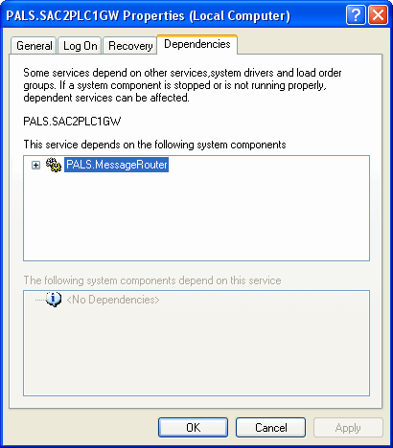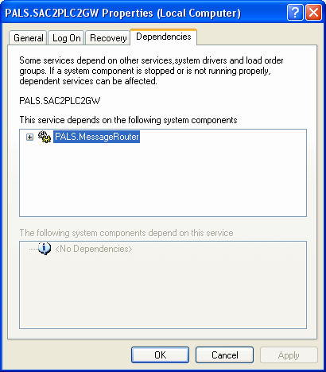
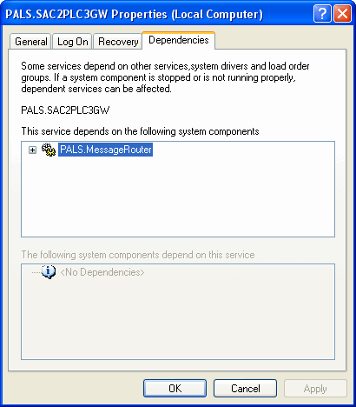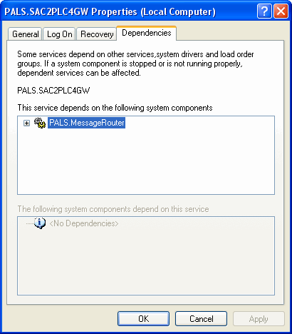

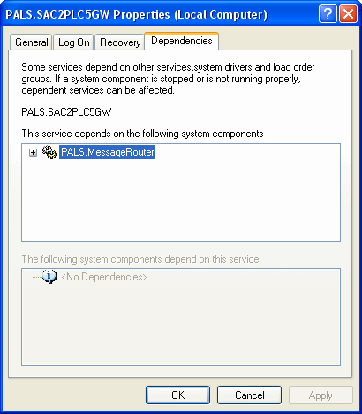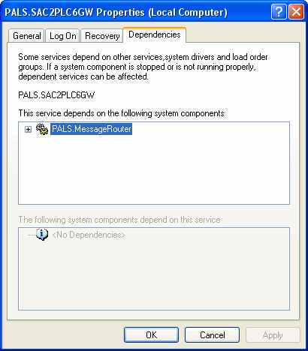
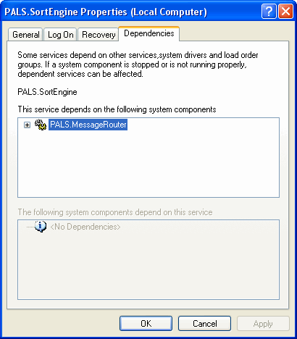

Hence, MessageRouter service will be started automatically when SAC2PLC1GW, SAC2PLC2GW, SAC2PLC3GW, SAC2PLC4GW, SAC2PLC5GW, SAC2PLC6GW, or SortEngine service is started.

Similarly, all SAC2PLC1GW, SAC2PLC2GW, SAC2PLC3GW, SAC2PLC4GW, SAC2PLC5GW, SAC2PLC6GW, and SortEngine services will be stopped automatically when MessageRouter service is stopped.
